Design and implementation solar tracker



**Department: Electrical and electronics engineering**

**Option: Electrical technology**

**Level: Three**

**Names: 1. GIKUNDIRO Shaffi Omar**

**2. NSANZIMANA Fabrice**

**Abstract**

As population is increasing globally, we are very concerned for electricity. There are various ways of electricity generation like hydro power plant, nuclear power plant, windmill plants and also solar power plants.

The former two are non-renewable source of energy; hence we cannot depend only on such technology. Also harnessing energy from hydro and nuclear is equally difficult. The letter two are renewable source of energy, nowadays we have lots of power plants established on solar and wind technology. Our project aims at Dual axis or Dual direction tracker. The solar panel used in this system can adjust its direction both in X-Y co-ordinates. This helps better directivity with sun rays, thus increase the efficiency of the solar system.

**Problem statement**

There are many problems that occur in the previous type of solar tracking system. The problem here is the solar panel that is use only in fixed installation. Because of this problem, the power that can be generated is low. The other problem is the price for the solar tracking system is very expensive for the family that use more power than usual because its need to install more than one solar panel to produce enough power. So this project is to fix the problem that occurs. This solar tracking system can detect a 180 degree of rotation. So the solar panel that can be generating here is very high compare to when the solar panel can only stay in one direction.

The other problem is related with the solar energy. The fixed solar panels do not aim directly to the sun due to the constant motion of earth. As the result the power produce by this device is not the maximum it should produce. The better solution for this system to get the maximum output power is solar tracking system. This is the main reason the project solar tracker is made. The solar tracker will follow the sunlight to get more output power. Indirectly it will reduce the cost of buying more solar panels. These systems also reduce the time for users to change the position of solar panel to face the sun.

**Block diagram and description**

Bottom right LDR

Bottom left LDR

Top right LDR

Top left LDR

Microcontroller

Shaft coupler

Motor 2

(for Y-axis rotation)_

Motor 1

(for X-axis rotation)_

Shaft coupler

Solar panel

**Light dependent resistor**

Light dependent resistor (LDR) is made of high-resistance semiconductor. It can also be referred to as a photoconductor. If light falling on the device is of the high enough frequency, photons absorbed by the semiconductor give bound electrons enough energy to jump into the conduction band. The resulting free electron conducts electricity, thereby lowering resistance. Hence, Light dependent resistor (LDR) is very useful in light sensor circuits. LDR is very high-resistance, sometimes as high as 1000 000ohms, when they are illuminated with light resistance drops dramatically.

**Microcontroller**

A microcontroller is embedded inside of a system to control a singular function in a device. It does this by interpreting data it receives from its I/O peripherals using its central processor. The temporary information that the microcontroller receives is stored in its data memory, where the processor accesses it and uses instructions stored in its program memory to decipher and apply the incoming data. It then uses its I/O peripherals to communicate and enact the appropriate action.

Microcontrollers are used in a wide array of systems and devices. Devices often utilize multiple microcontrollers that work together within the device to handle their respective tasks.

For example, a car might have many microcontrollers that control various individual systems within, such as the anti-lock braking system, traction control, fuel injection or suspension control. All the microcontrollers communicate with each other to inform the correct actions. Some might communicate with a more complex central computer within the car, and others might only communicate with other microcontrollers. They send and receive data using their I/O peripherals and process that data to perform their designated tasks.

**Power supply**

A power supply is an electrical device that offers electric power to an electrical load such as laptop computer, server, or other electronic devices. The main function of a power supply is to convert electric current from a source to the correct voltage, current, and frequency to power the load. It could be AC to DC or DC to DC. Consequently, power supplies are sometimes regarded as electric power converters. Some power supplies are standalone and separated from equipment to be external power supplies and others inside the device to be the internal power supplies.

Every power supply has a power input connection, which gets energy from a source, and single or multiple power output connections that transmit current to the electrical load.

The power source could be from the electric power grid, which generally provides AC, such as an electrical outlet and energy storage devices, which commonly offer DC, such as solar power devices, batteries, generators, or another power supply.

**Servo motors**  
servo contain a small DC motor, a gearbox and some control circuitry, and feed on 5 volts at about 100mA maximum, and about 10-20mA when idle. They have a three-wire connector, one common wire (0 volt, usually black), one +5v wire (usually red), and one signal wire. In normal use they are controlled by pulses of about 2 to 2 milli-seconds at a repetition rate of about 50 per second. A short pulse makes the servo drive to one end of the travel, a long pulse makes it drive to the other end, and a medium one puts it somewhere proportionally between, some servos have gear components that allow them to rotate continuously. This method needs the servo to have a feedback potentiometer used by internal circuits to measure the position of the output shaft. If this is disconnected and the wires taken to an external pre-set potentiometer, the servo will drive continuously in one direction if fed with short pulses and vice-versa. If there are no pulses, the servo stops. It is uses to drive the solar tracker eastward and westward. The pulses are at normal TTL levels. The speed though, is not greatly affected by the pulse repetition rate, as long as it is above about 30 per second. These pulses can easily be provided by an output port of just about any computer, for instance the data or control lines of a printer port or a serial port, or a simple addressed latch added to the memory circuits. A possible configuration is the tricycle described above, with one driving and steering-wheel at the front and two idler wheels at the rear. Using a radio controlled (RC) servo for steering is a good method, because the position of the steering mechanism is determined by the length of the servo drive pulse, which can be generated by a software countdown loop or a hard-ware counter. If an RC servo is used as a drive motor, wheel motion sensors are needed on at least one wheel as in any DC motor.

**Solar panel**

Solar panel is the main point of the project. It involves solar panel to get voltage output. This is the renewable energy that needs to convert into voltage. This solar need more study and do the experiment to know the range of the output value. This solar panel will be controlled by software to switch on the circuit that will be converted the output and stabilize the voltage that be used in the project.

**Circuit diagram**

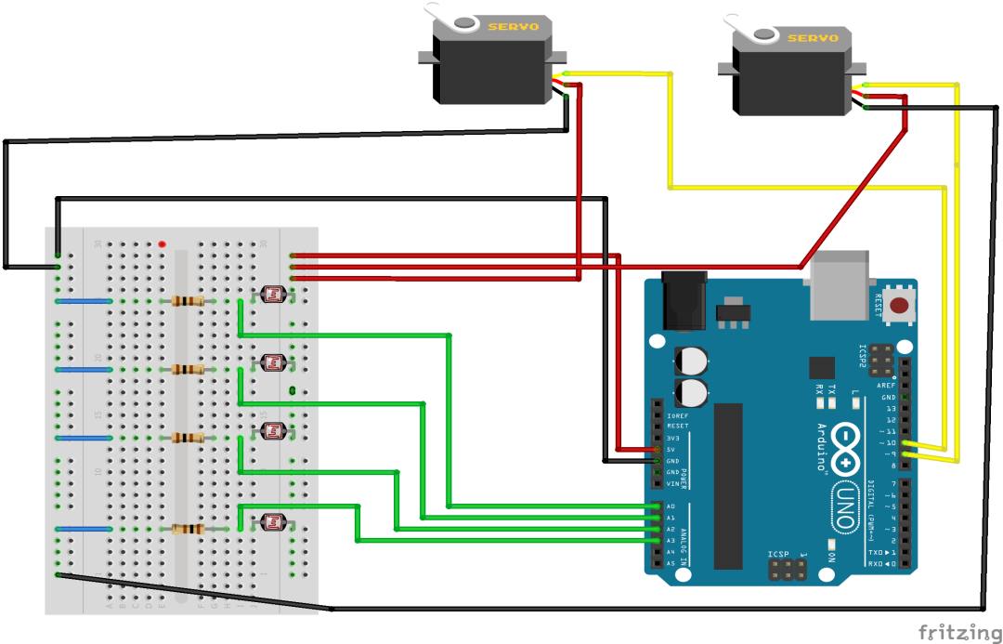

**Arduino IDE source code**

#include <**Servo**.h>

//defining Servos

**Servo** servohori;

int servoh = 0;

int servohLimitHigh = 160;

int servohLimitLow = 20;

**Servo** servoverti;

int servov = 0;

int servovLimitHigh = 160;

int servovLimitLow = 20;

//Assigning LDRs

int ldrtopl = 2; //top left LDR green

int ldrtopr = 1; //top right LDR yellow

int ldrbotl = 3; // bottom left LDR blue

int ldrbotr = 0; // bottom right LDR orange

void setup ()

{

 servohori.attach(10);

 servohori.write(0);

 servoverti.attach(9);

 servoverti.write(0);

 delay(500);

}

void loop()

{

 servoh = servohori.read();

 servov = servoverti.read();

 //capturing analog values of each LDR

 int topl = analogRead(ldrtopl);

 int topr = analogRead(ldrtopr);

 int botl = analogRead(ldrbotl);

 int botr = analogRead(ldrbotr);

 // calculating average

 int avgtop = (topl + topr) / 2; //average of top LDRs

 int avgbot = (botl + botr) / 2; //average of bottom LDRs

 int avgleft = (topl + botl) / 2; //average of left LDRs

 int avgright = (topr + botr) / 2; //average of right LDRs

 if (avgtop < avgbot)

 {

   servoverti.write(servov +1);

   if (servov > servovLimitHigh)

    {

     servov = servovLimitHigh;

    }

   delay(10);

 }

 else if (avgbot < avgtop)

 {

   servoverti.write(servov -1);

   if (servov < servovLimitLow)

 {

   servov = servovLimitLow;

 }

   delay(10);

 }

 else

 {

   servoverti.write(servov);

 }

 if (avgleft > avgright)

 {

   servohori.write(servoh +1);

   if (servoh > servohLimitHigh)

   {

   servoh = servohLimitHigh;

   }

   delay(10);

 }

 else if (avgright > avgleft)

 {

   servohori.write(servoh -1);

   if (servoh < servohLimitLow)

    {

    servoh = servohLimitLow;

    }

   delay(10);

 }

 else

 {

   servohori.write(servoh);

 }

 delay(50);

}

**Proteus simulation**

